**SOFTWARE REQUIREMENT SPECIFICATION** **DOCUMENT**

**CALCULATE WITH ME SYSTEM**

**Version:** 1.0



**ABSTRACT**

This document is intended to be the SRS for developing **CALCULATE**



| **Project Title** | **CALCULATE WITH ME SYSTEM** | | |
| --- | --- | --- | --- |
| **Lead Institution** | **INTERNATIONAL SCHOOL - DUY TAN UNIVERSITY** | | |
| **Project Mentor** | **Mr. Nguyen Dang Quang Huy** | | |
| **Team Name** | **TEAM 5** | | |
| **Team Members** | **Nguyen Thi Men** | | |
| **Nguyen Huu Thang** | | |
| **Le Trung Dung** | | |
| **Le Thanh Nhat Minh** | | |
| **Tran Thi Nhu Ngoc** | | |
| **Start Date** | January 22, 2024 | **End Date** | January 29, 2024 |

**ROPRIETARY INFORMATION**: The information contained in this document is the property of **TEAM 5**. Except as specifically authorized in writing by **TEAM 5**, the holder of this document shall keep all information contained herein confidential and shall protect same in whole or in part from disclosure and dissemination to all third parties

**Table of Contents**

Revision History 3

1. Introduction 4

1.1. Purpose 4

1.2. Intended Audience and Suggested Reading 4

1.3. References 4

2. Project Overview 4

2.1. Project Description 4

2.2. Business Need 4

2.3. Project Analyst 5

2.3.1. Business Function Diagram 5

2.3.2. System Context Diagram 5

2.4. Software Requirement Specification 6

2.4.1. High-level Functional Requirement (FR) 6

2.4.2. Stakeholders 6

2.4.3. Use case 6

UC 01: Enter Number 7

UC.02:Calculate 8

UC.03: Reset 9

UC.04:Exit 10

2.4.6. Activity Diagrams 13

# Revision History

| **Date** | **Change item** | **Description** | **by** | **Version** |
| --- | --- | --- | --- | --- |
| **22/1/2024** | Receive requests from customers | After preparing questions about the request and receiving requests from customers | All members | Version 1.0 |
| **23/1/2024** | Start team meeting | Meet and refer to some documents, then focus on implementing the project. The team can fully understand the system requirements after the meeting | All members | Version 1.0 |
| **23/1/2024** | Work analysis | Through specific requirements and analysis, speaking, the leader needs to prepare in advance for the members. | All members | Version 1.0 |
| **23/1/2024** | Assign work | Get BFD, context diagram, use case, use case specification, and activity diagrams. The mandatory rules of the project | Nguyen Thi Men | Version 1.0 |
| **23/1/2024** | Conduct the work | Team members complete the tasks assigned by the team leader. And submit the report on time to the team leader | All members | Version 1.0 |
| **24/1/2024** | Edit the report | The group leader receives reports from group members, then reviews and revises them as required | Nguyen Thi Men | Version 1.0 |
| **25/11/2024** | Complete the SRS file | Complete BFD, context diagram, use case, use case specification, and activity diagrams. | Nguyen Huu Thang, Tran Thi Nhu Ngoc | Version 1.0 |

# Introduction

## Purpose

This document describes the computing system including all information features needed in detail for implementation. The purpose of this document is as follows:

• To assist project managers have an overall view of the system as well as perform tasks in an optimized way

• To Describes the control architecture and use cases in detail. Based on this document

Architectural analysts and designers will be able to develop the system easily.

• Intended Audience

## References

| Intended Audience | everyone |
| --- | --- |
| Project manager | High-level functional requirement |
| Architect analyst and designer | Overall description and user cases to architect and design the system |
| Quality control | Overall description and user cases |
|  |  |

# Project Overview

## Project Description

A computer system, a compact device, designed to perform basic mathematical operations such as addition, subtraction, multiplication, division, and other related operations. The main goal of this system is to support pupils, students and workers in performing mathematical operations accurately, quickly and conveniently. This system is capable of handling complex calculations or involving many numbers accurately, helping to avoid errors arising from human intervention. This feature not only helps users save time and effort, but also increases work efficiency, especially in fields that require large calculations.

## Business Need

This system had a number of advantages:

- Supports performing calculations quickly and accurately.

-Helps save time and ensures accuracy in the calculation process

- Support students and people working on problems that require complex calculations or require high accuracy

## Project Analyst

### Business Function Diagram

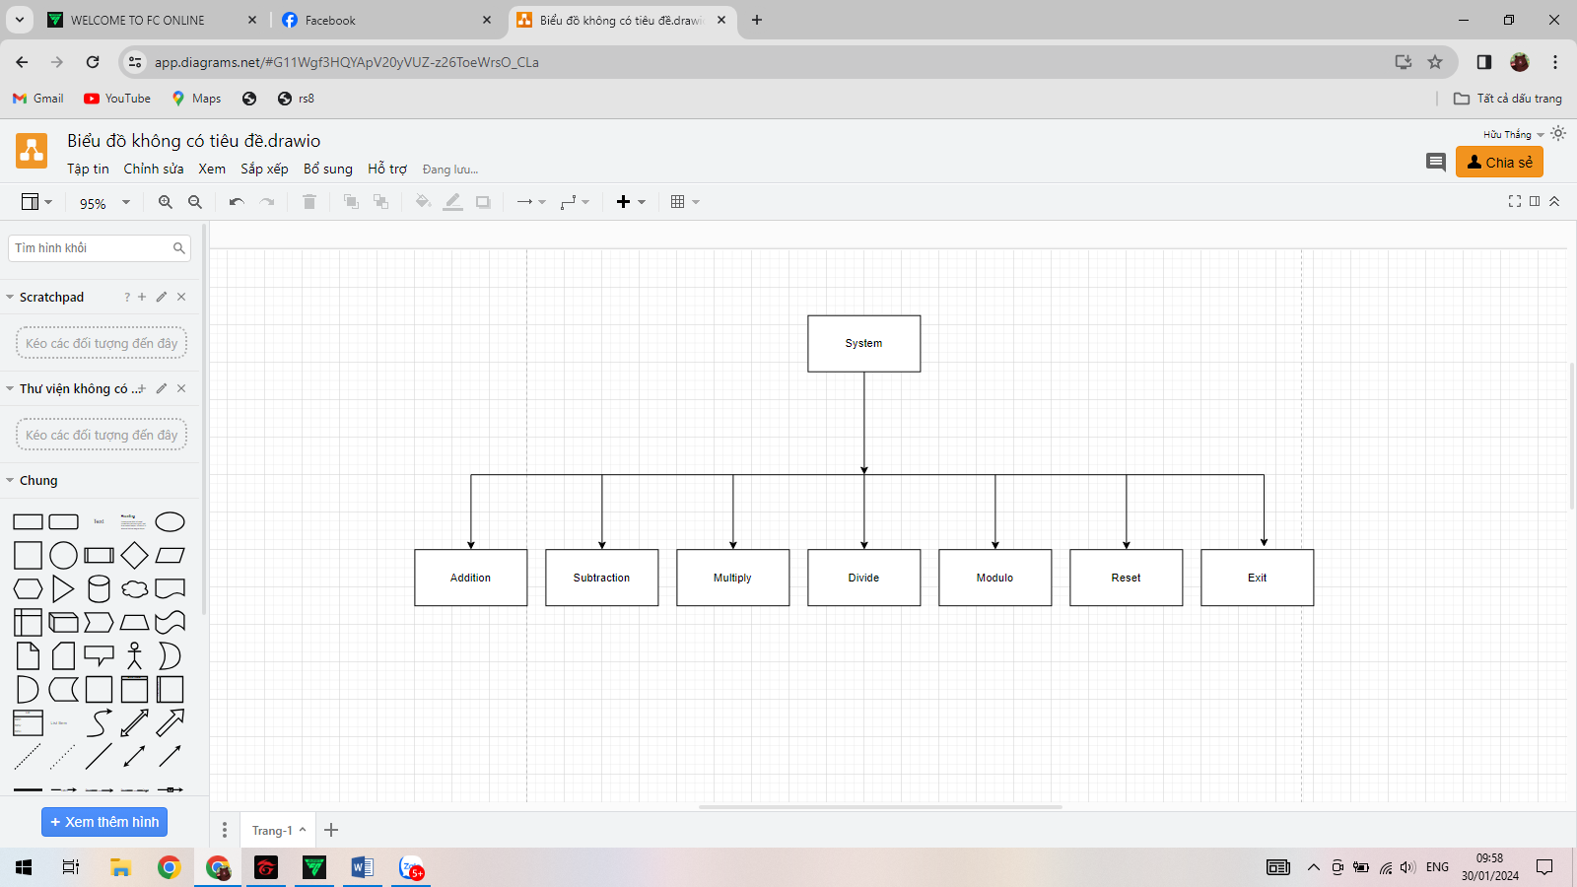

### System Context Diagram

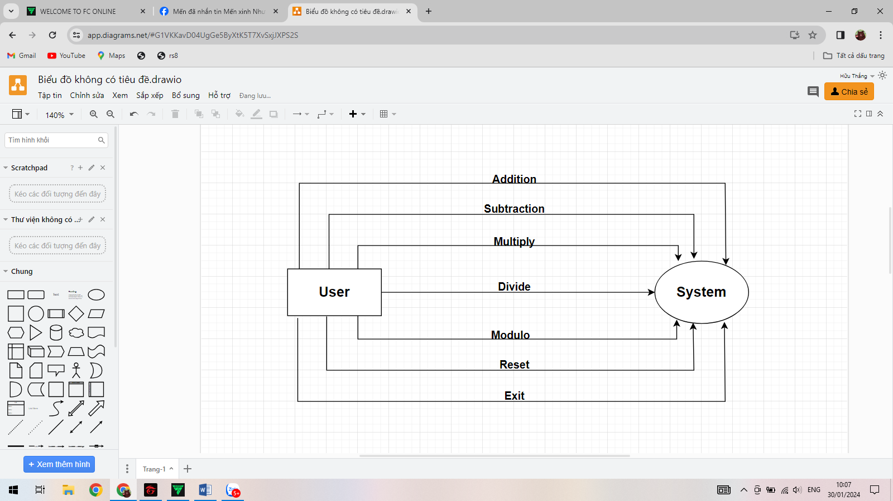

## Software Requirement Specification

### High-level Functional Requirement (FR)

| FR1.1 | **Title** | **Enter Number** |
| --- | --- | --- |
| **User** | This use case allows users to enter numbers to be calculated into the system. |
| Description | The system displays the interface for users to enter natural numbers or decimals |
| FR1.2 | **Title** | **Addition, Subtraction,Multiplication, Divide** |
| **User** | Allows users to select the calculation to calculate |
| Description | To perform calculations, users need to enter two or more numbers along with plus, minus, multiplication, and division signs. The system will calculate these numbers and display the results. |
| FR1.3 | **Title** | **Reset** |
| **User,System** | This user case allows deleting all entered numbers and the system can also self-delete when the user does not enter correctly. |
| Description | When the user presses the "Reset" button, the system will usually delete all the data just entered and when the user only enters letters or numbers and letters, the system will report an error and automatically reset to the original state. |
| FR1.4 | **Title** | **Exit** |
|  | **User** | This user case allows the user to exit the program |
|  |  | When the user receives results or cancels a mode pressing the "Exit" button, the system will automatically exit the mode or stop the running program. |

### 2.4.2. Stakeholders

| **Stakeholder** | **Description** |
| --- | --- |
| Users | System users |

### 2.4.3. Use case

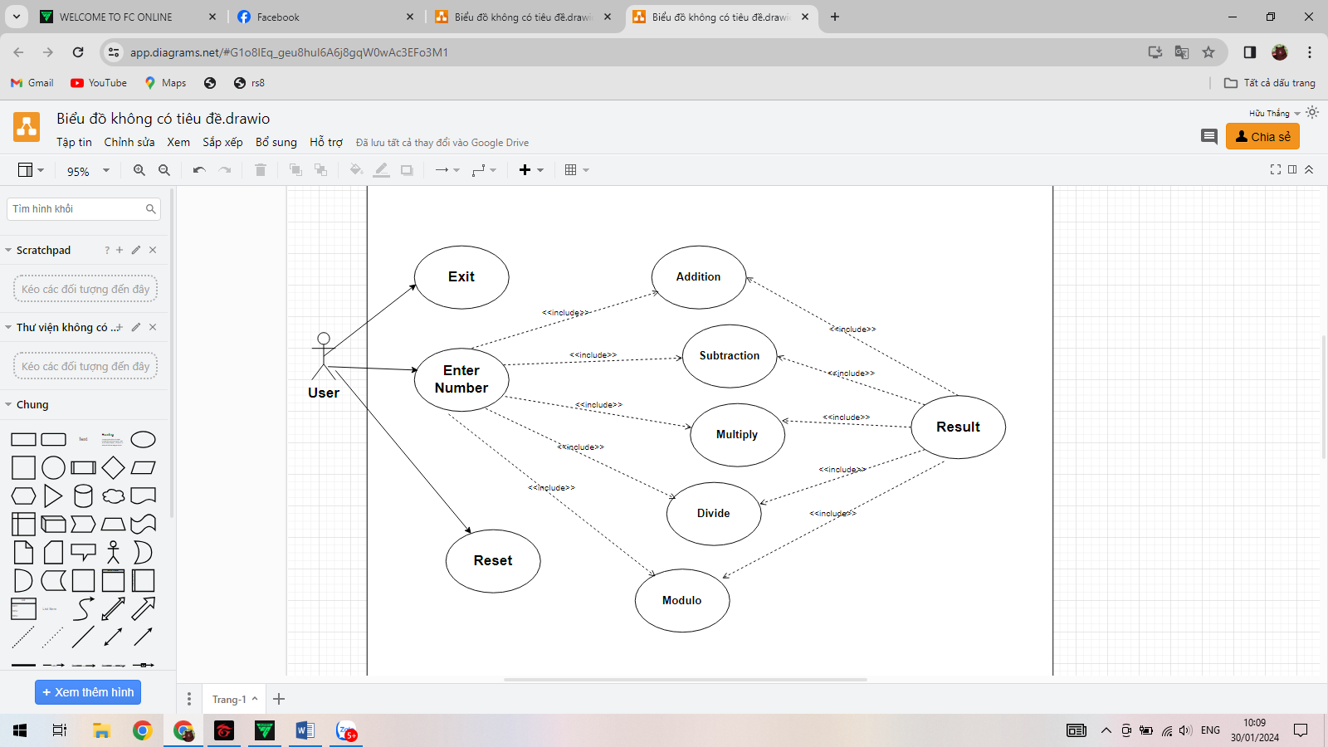

**2.4.4. List of use case**

| **Use case ID** | **Use case name** | **Functional Req.** |
| --- | --- | --- |
| UC.01 | Enter Number | FR.1 |
| UC.02 | Select Addition | FR.2 |
| UC.03 | Select Subtraction | FR.3 |
| UC.04 | Select Multiply | FR.4 |
| UC.05 | Select Divide | FR.5 |
| UC.06 | Select Modulo | FR.6 |
| UC.07 | Reset | FR.7 |
| UC.08 | Exit | FR.8 |

**2.4.5. Use Case Specification**

##### UC 01: Enter Number

1. Use Case Diagram

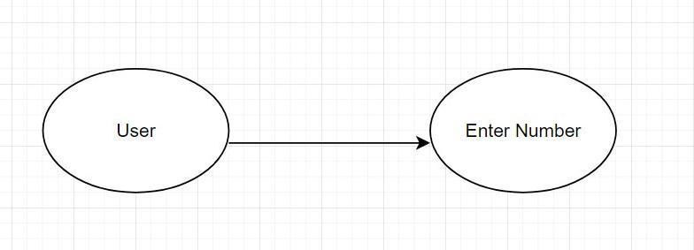

1. Use Case Specification

| Use case ID | UC.01 | | |
| --- | --- | --- | --- |
| Use case name | **Enter Number** | | |
| Create by | Huu Thang | **Last updated by** | Huu Thang |
| Date created | Jan 22, 2024 | **Date last updated** | Jan 30,2024 |
| Actor | Users of the system : User | | |
| Description | The person needs to enter the numbers to be calculated to be able to receive the results after calculation. | | |
| Trigger | Click on the 2 textfile bars of A and B | | |
| Pre-condition | None | | |
| Post-condition | If you only enter numbers, you will get the most accurate results. But if you enter letters or numbers and letters, the system will report an error and automatically reset and return the blank box as before. | | |
| Main Success Scenario: | **Step** | **Actor Action** | **System Response** |
| 1 | Click on the 2 textfile bars of A and B |  |
|
|
| Exception | **Step** | **Actor Action** | **System Response** |
| 1 | If you enter characters or both numbers and characters. | Display error message and automatically reset for user to re-enter |
| Priority | High | | |
| Business rule | N/A | | |
| Description: | When users want to calculate they need to enter the number to calculate into the system. | | |

##### UC.02: Calculate

1. Use Case Diagram   
   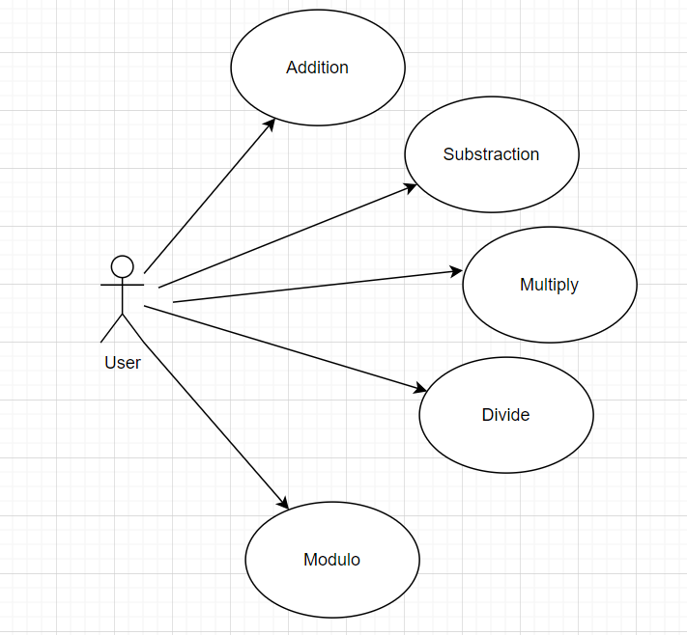
2. Use Case Specification

| Use case ID | UC.02 | | | | |
| --- | --- | --- | --- | --- | --- |
| Use case name | **Calculate** | | | | |
| Create by | Huu Thang | | **Last updated by** | | Huu Thang |
| Date created | Jan 23,2024 | | **Date last updated** | | Jan 27,2024 |
| Actor | User | |  | | |
| Description | When the user has entered the correct number, you can choose a calculation to calculate the result. | | | | |
| Trigger | The required number has been entered correctly. | | | | |
| Pre-condition | Before calculating, users need to enter the correct number required by the system. | | | | |
| Post-condition | Users will receive results if they enter the numbers according to the system's requirements. | | | | |
| Main Success Scenario: | **Step** | **Actor Action** | | **System Response** | |
| 1 | The user must click on one of the five calculation“**Addition, Subtraction, Multiply, Divide , Modulo** ”buttons. | | The system will display the results if the correct number is entered. | |
|
|
| Alternative Scenario | **Step** | **Actor Action** | | **System Response** | |
| 1 | The user must click on one of the five calculation “**Addition, Subtraction, Multiply, Divide, Modulo**” buttons. | | The system will display the results if the correct number is entered. | |
|
|
| Exceptions | **Step** | **Actor Action** | | **System Response** | |
| 1 | None | | None | |
|
|
| Priority | High | | | | |
| Business rule | N/A | | | | |
| Description: | When the user has entered the correct number, you can choose a calculation to calculate the result. | | | | |

##### UC.03: Reset

1. Use Case Diagram   
   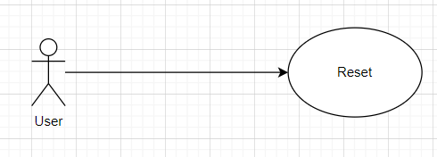
2. Use Case Specification

| Use case ID | UC.03 | | | | |
| --- | --- | --- | --- | --- | --- |
| Use case name | Reset | | | | |
| Create by | Huu Thang | | **Last updated by** | | Huu Thang |
| Date created | Jan 23,2024 | | **Date last updated** | | Jan 27,2024 |
| Actor | User | |  | | |
| Description | Users can press the reset button if they want to re-enter two numbers A and B | | | | |
| Trigger | The required number has been entered correctly. | | | | |
| Pre-condition | None | | | | |
| Post-condition | None | | | | |
| Main Success Scenario: | **Step** | **Actor Action** | | **System Response** | |
| 1 | Click “Reset” button. | | The system will delete 2 numbers A and B for the user to re-enter. | |
|
|
| Alternative Scenario | **Step** | **Actor Action** | | **System Response** | |
| 1 | Click “Reset” button. | | The system will delete 2 numbers A and B for the user to re-enter. | |
|
|
| Exceptions | **Step** | **Actor Action** | | **System Response** | |
| 1 | None | | None | |
|
|
| Priority | High | | | | |
| Business rule | N/A | | | | |
| Description: | Users can press the reset button if they want to re-enter two numbers A and B | | | | |

##### UC.04: Exit

1. Use Case Diagram   
   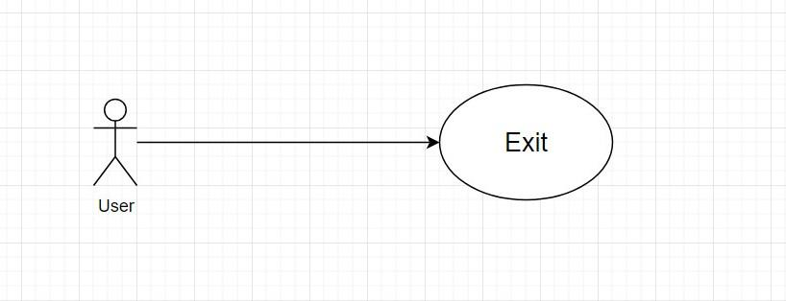
2. Use Case Specification

| Use case ID | UC.03 | | | | |
| --- | --- | --- | --- | --- | --- |
| Use case name | **Exit** | | | | |
| Create by | Huu Thang | | Create by | | Huu Thang |
| Date created | Jan 23,2024 | | Date created | | Jan 23,2024 |
| Actor | User | | Actor | | |
| Description | When user have finished calculating or do not want to use it anymore, user can exit with "Exit". | | | | |
| Trigger | User can exit anytime user want. | | | | |
| Main Success Scenario: | **Step** | | | | |
| Post-condition | 1 | | | | |
| Main Success Scenario:  Alternative Scenario |  | **Actor Action** | |  | |
|  | Enter information in the "First Number" box and "Second Number" box. | |  | |
| **Step** | Alternative Scenario | | **Step** | |
| 1 | Click the / button | | 1 | |
| Exceptions  Priority |  | **Actor Action** | |  | |
|  | The information entered is not a number | |  | |
| High | Priority | | High | |
| Business rule | N/A | | | | |
| Description: | After getting the results or not wanting to use the calculation anymore, the user can exit by clicking the "**Exit**" button. | | | | |
| Use case ID | UC.03 | | | | |

## 2.4.6. Activity Diagrams

